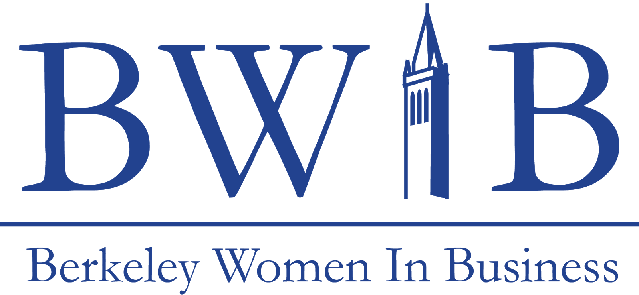

Spring 2018 Committee Member Application
CORPORATE RELATIONS COMMITTEE

Contact Information

Name:
Year:
Major:
Phone Number:
Email Address:

Committee Preferences
Please fill in your first and second choices of committees in the numbered ranking below. One of your choices must be Corporate Relations. For reference, here is a list of the 7 committees:

Marketing
Finance
Corporate Relations
Administration
Community Development
University Relations
Technology & Communications

Section I
Please answer the following questions, limiting your responses to 250 words each.

- How did you hear about BWIB?
- Why do you want to join the Corporate Relations Committee and what do you hope to gain from the experience?
- What makes you qualified to become a member of the Corporate Relations Committee? Highlight some of your experiences and strengths.

Section II
Please answer the following questions, limiting your responses to 300 words each.

- Explain what professionalism means to you and describe a situation where you had to display professionalism.
- Pitch a professional development workshop event for BWIB: what industry, company, topic & format would you pick? Why? Briefly explain how you would go about it.

Section III
Please answer the following questions, try to be as succinct as possible.

- What is your availability for this semester? What other commitments do you have? Include the dates and times that you unable to meet.
- In order to become a committee member, you must be able to attend Committee Orientation on February 15th from 6-8 PM. Will you be available?

Section IV

Along with this completed application, it is required you submit a copy of your resume and a copy of your class schedule. The resume must be in PDF format. Failure to submit both these documents alongside your application will result in ineligibility for a committee position.

Please email your completed application to Ishita Rustagi, the Vice President of Corporate Relations, by Tuesday, February 6, 2018 at 11:59 PM to be considered for a position. Your application must be in PDF format.

Ishita Rustagi – Vice President of Corporate Relations
corporate@berkeleywomeninbusiness.com

If you have any other questions, please feel free to reach out to:
President - Pallavi Chadha
president@berkeleywomeninbusiness.com

The next step in the application process is an interview. You will be contacted by Thursday, February 8th.

